

Mahadi Hasan Kamrul

152-15-5879

Simulation Lab Report

Single Queue With PYTHON

Sample Problem

A small grocery shop has one checkout counter.Customer arrrives at the checkout counter at random from 1 to 8 minutes apart. Each possible value of inter-arrival time has the same possibility of occurrence.The service time varies from 1 to 6 minutes with the possibility shown below.The problem is to analyze the system by simulating the arrival time and service time of 6 customers.

Informations:

* Service Time: [1,2,3,4,5,6]
* Probability: [0.10,0.20,0.30,0.25,0.10,0.05]
* Random Digit For Arrival: [913,727,15,948,304,922]
* Random Digit For Service Time: [84,10,74,53,17,79]

Python Code:

Codes for the distribution of Arrival Time Table:

RANDOM DIGIT GENERATION FOR ARRIVAL TIME:

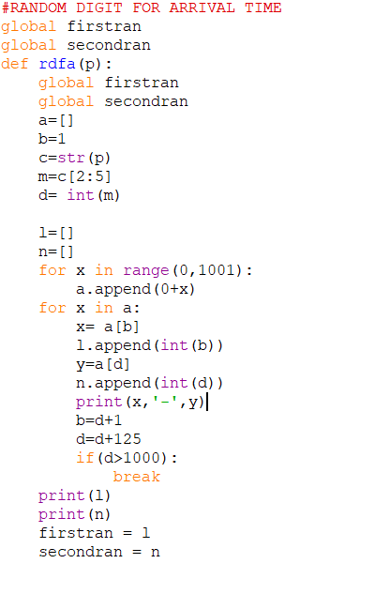

DISTRIBUTION OF ARRIVAL TIME:

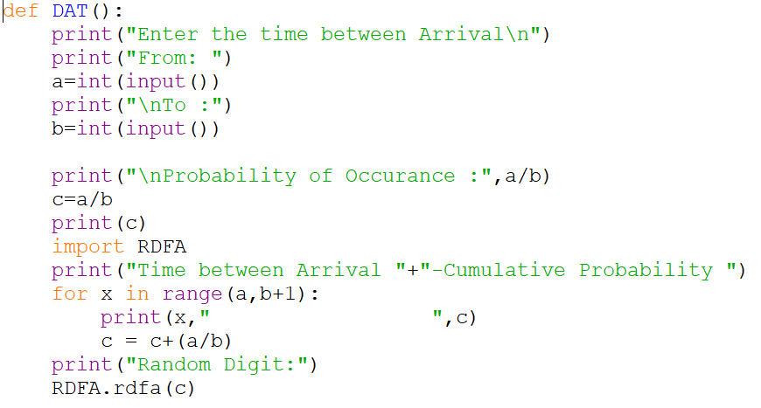

Codes for the distribution of Service Time Table:

ENTER PROBABILITY FOR SERVICE TIME

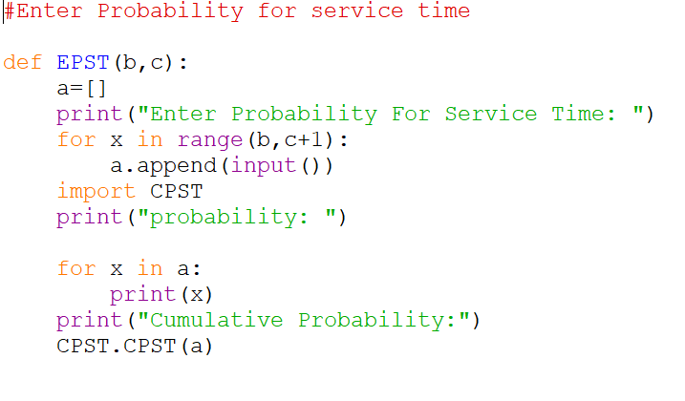

DISTRIBUTION OS SERVICE TIME

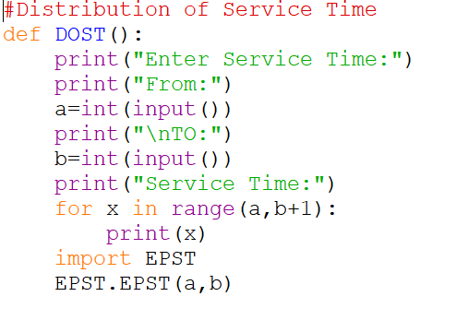

RANDOM DIGIT GENERATION FOR SERVICE TIME

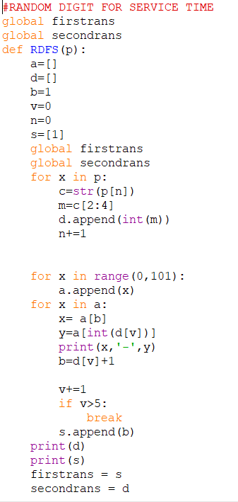

CUMULATIVE PROBABILITY FOR SERVICE TIME

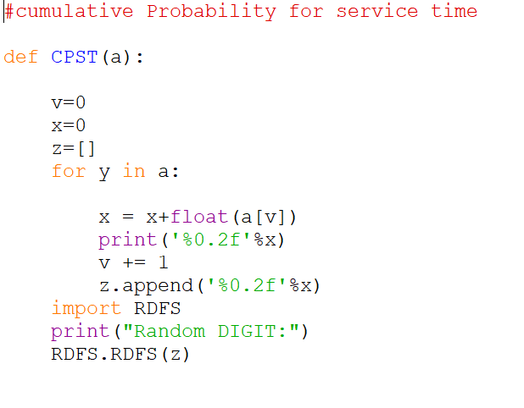

Codes for the Time Between Arrival Determination Table:

Time Between Arrival Determination

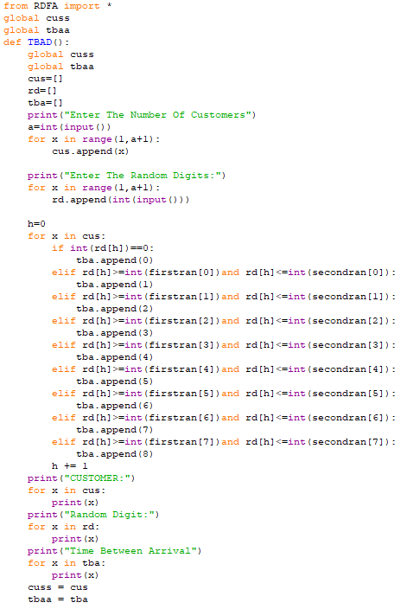

Codes for the Service Time Table:

Service Time

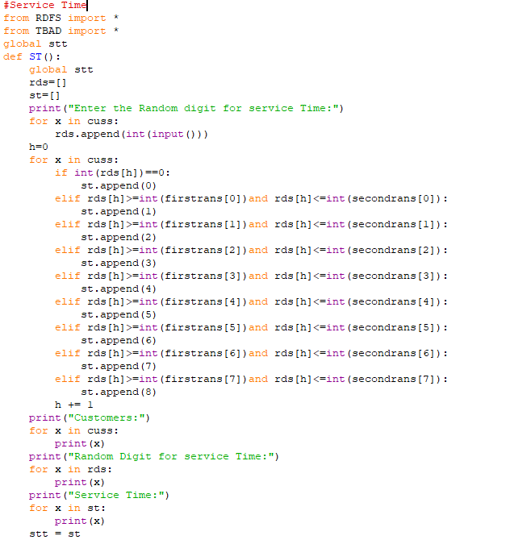

Codes for the Final Table:

Final Table

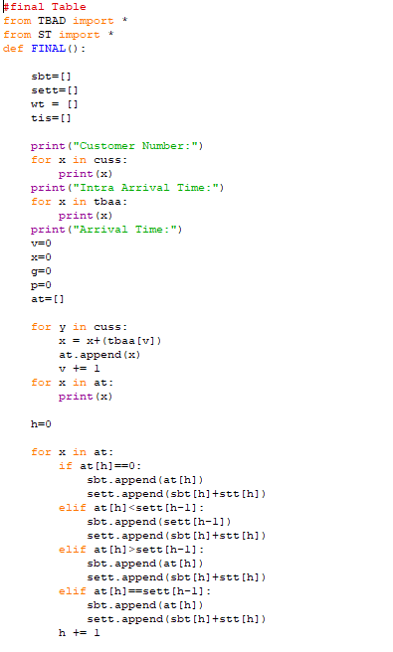 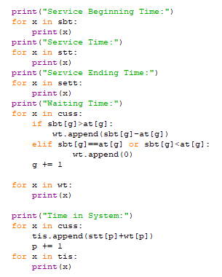

Main Segment:

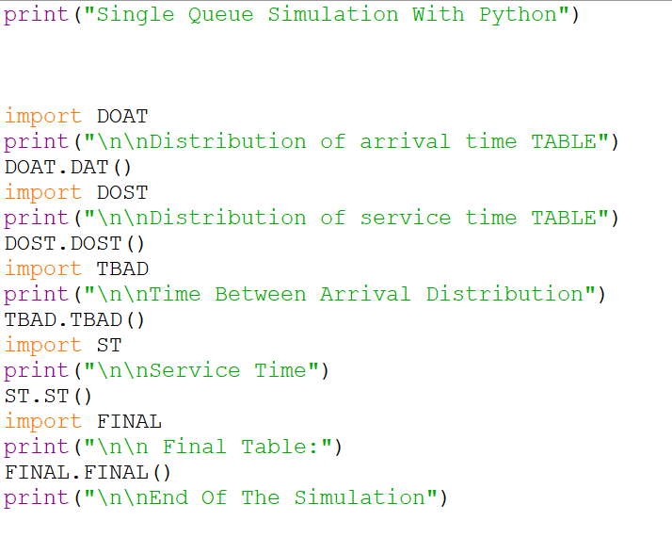

User Manual

**MAIN = MAIN FILE**

**DOAT= DISTRIBUTION OF ARRIVAL TIME**

**RDFA = RANDOM DIGIT GENERATION FOR ARRIVAL TIME (CALLED IN DOAT)**

**DOST= DISTRIBUTION OS SERVICE TIME**

**EPST= ENTER PROBABILITY FOR SERVICE TIME (CALLED IN DOST)**

**CPST= CUMULATIVE PROBABILITY FOR SERVICE TIME (CALLED IN EPST)**

**RDFS= RANDOM DIGIT GENERATION FOR SERVICE TIME (CALLED IN CPST)**

**TBAD= TIME BETWEEN ARRIVAL DISTRIBUTION (CALLED IN MAIN) (LIST GENERATED FROM RDFA)**

**ST= SERVICE TIME (CALLED IN MAIN) (LIST GENERATED FROM RDFS AND RDFA)**

**FINAL= FINAL TABLE (CALLED IN MAIN)**